(Approx. 277 words)

Windows Corner – File Extensions
By Rosita Herrick, Windows 10 Forum Host and Windows 10 Apps Teacher, The Sarasota Technology Users Group, FL
May 2017 issue, STUG Monitor
www.thestug.org
hrosita (at) aol.com

Each file created on a computer gets a file type definition or extension expressed by the characters after the period.

Here are some examples:
- Wordpad creates .rtf files
- Microsoft Office Word 2007 and newer creates .docx files
- Pictures come with different extensions depending on the device that created them. Some of them are .png, .jpg, .raw .tiff, and others.

When a user opens a file, normally there is a default program assigned to the extension that will open the file. In Windows 10 it is the Photos app. However, sometime I want to open a file with another program that I know can open it. In this case I would rather open a .jpg picture with one of my favorite free picture browser programs called Irfanview. It is a small, fast program that lets me browse pictures fast and even lets me do some quick manipulation.

I know that I can right click on the file and in the popup select “Open with” and will get a number of options.
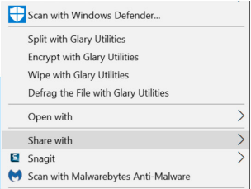



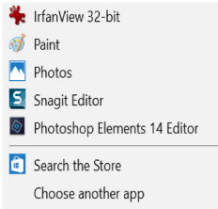

But if I want to open .jpg pictures with Irfanview by default and skip a few clicks, I need to click on the “Choose another app” link.

As you can see in the picture above, the popup is a little different. I highlighted the program name, and placed a check in the box to always use this app to open .jpg files. By clicking OK I now have changed the default program that opens the .jpg file extension.

